StoLaM+ results of
control mesocosm simulations

Dr. Tido Strauss
Jana Gerhard

gaiac - Research Institute for Ecosystem Analysis and Assessment
Kackertstr. 10
52072 Aachen
Germany

March 29, 2022

1 Introduction 3
1.1 Conversion factors 3
1.2 Emergence data as calibration and validity endpoint for insects instead of larval counts 4
1.3 Comments on unmet validity criteria 7
2 Results StoLaM 10
2.1 Phytoplankton 10
2.1.1 Green algae 10
2.1.2 Diatoms 12
2.1.3 Cryptophytes 14
2.1.4 Total Chlorophyll-a 16
2.2 Zooplankton 18
2.2.1 Daphnids 18
2.2.2 Copepod nauplii 20
2.2.3 Predatory (cyclopoid) copepods 22
2.2.4 Rotifera 24
3 Results IBM Chaoborus 26
3.1.1 Chaoborus crystallinus 26
4 Results StreamCom 28
4.1 Macroinvertebrates 28
4.1.1 Asellus aquaticus 28
4.1.2 Gammarus 30
4.1.3 Gastropoda 32
4.1.4 Cloeon dipterum 34
4.1.5 Chironomus riparius 38
4.2 Total periphyton (chlorophyll-a) 42

Introduction

The years 2014, 2016, 2018, and 2019 were simulated with different weather data.
All simulations start at the beginning of the respective year (01 January). Only the benthic macroinvertebrates modeled with StreamCom were simulated with a one-year lead. The 2013 weather dataset was used for this purpose.
The initial values of the state variables were adjusted in the parameterization process and are valid for all simulated years. This means that differences between studies are not considered using the first measured data of a specific study as starting values, but each simulated year starts with the same starting values adjusted for the whole mesocosm data set. This possibly reduces the match of simulation results with a concrete year-specific data set, but increases the generality of the model within the data set used.

The underlying nutrient dynamics, which are strongly influenced by macrophytes and their nutrient release, and the simulated water temperatures are not shown in this document.

Conversion factors

The conversion factors given in Table 1 were used to back-calculate the simulation results.
For the benthic organisms, a missing conversion factor means equating the number of sampled animals to animals per m² in the model.

Table 1: Conversion factors used.
Taxon | Value | Unit | Comment
Phytoplankton (all taxa) | 6 | µg Chlorophyll-a per mg wet weight | Mean value of measurements across taxa, gaiac
Daphnids | none | Ind/L | IBM approach
Copepods and Nauplii | none | Ind/L | IBM approach
Rotifera | 0.275 | µg ww/Ind (0.055 µg dw/Ind) | Conversion from biomass to individuals
Chaoborus larvae | 0.006 | Ind per sample into Ind/L (Ind/L back-calculated from the simulated abundances for 1700 litres) | IBM approach, simulation of the total population
Periphyton | 0.024 | J / m2 into Chlorophyll-a / area | with:  185.5 cm2 / area,  6 µg Chla / mg ww,  4623 J / g ww
Asellus aquaticus | 0.5 | Ind per sample into Ind / m2 | IBM approach
Gammarus pulex | none | (Ind/sample equal to Ind/m2) | IBM approach
Gastropoda (Lymnea) | none | (Ind/sample equal to Ind/m2) | IBM approach
Cloeon dipterum larvae | 10* | Ind per sample into Ind / m2  *value estimated from simulations | IBM approach
Chironomidae larvae | 880* | Ind per sample into Ind / m2  *value estimated from simulations | IBM approach

Emergence data as calibration and validity endpoint for insects instead of larval counts

Due to the discrepancy between measured larval stages and emergence data, which is also known from other mesocosm studies, doubts arose in our research group at gaiac about the reliability of the methods used for representative quantification of larval density in mesocosms for emergent benthic insects (Cloeon and Chironomus).
The following considerations can only be made for taxa for which multiple independent endpoints have been measured as with emergent insects. For other taxa, such as Gammarus or Asellus, the representativeness of the measurement method cannot be evaluated.

From the above considerations, we attempted to derive new validity criteria for emergent benthic insect species. For the evaluation of emergence data, 6 studies were available (2014a, 2016a, 1018a, 2018c, 2019a, 2019b).
For calculating the number of emerged adults per m², it was assumed that on average 20 % of the mesocosm area (1.5 m²) was covered by emergence traps. Data gaps in the evaluation of weekly emergence samples were ignored, which tends to underestimate emergence. The resulting conversion factor from Ind/trap into Ind/m² is 3.33.
The resulting emergence data are given in Figure 1 (Cloeon) and Figure 2 (chironomids).

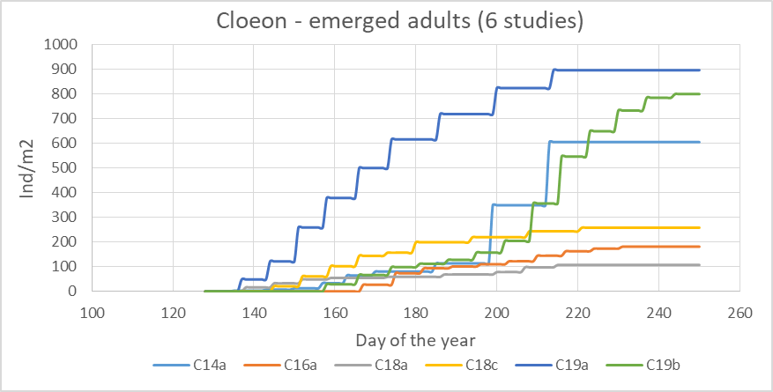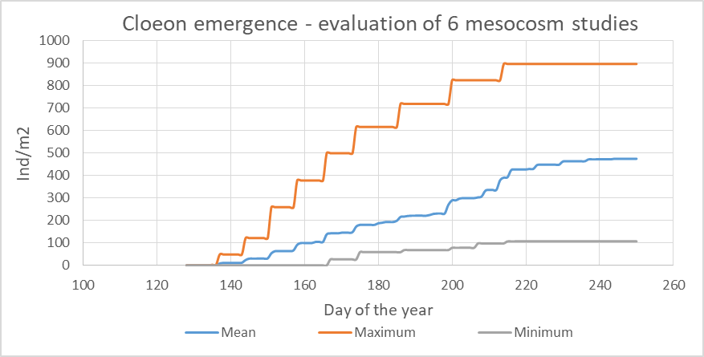
Figure 1: Cumulative plot of emerged adults of Cloeon [Ind/m²], individual mesocosm studies (left) and range and mean of all 6 studies (right).

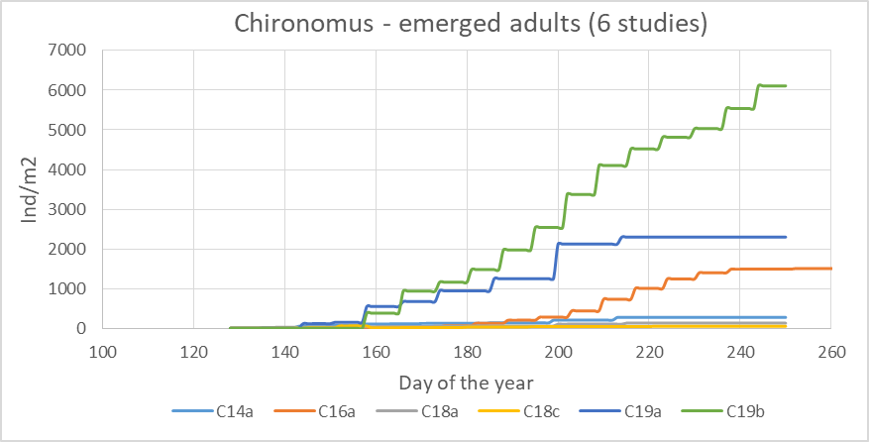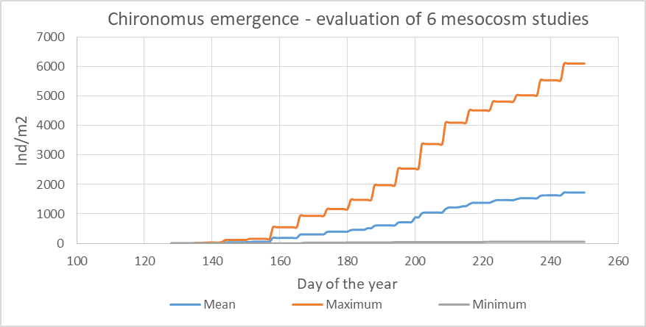
Figure 2: Cumulative plot of emerged adults of Chironomidae (without Tanypodinae, [Ind/m²]), individual mesocosm studies (left) and range and mean of all 6 studies (right).

As a validation criteria for emergence, we used the minimum and the maximum value of the cumulative emergence per species that must be met by the simulations at the end of the experimental mesocosm period (see Table Model_Calibration_Results-gaiac.xlsx).
Since a higher larval number was required to achieve the calculated emergence, a theoretical larval conversion factor was derived based on the comparison of simulated larval densities and the sampled values.

Although larval background mortality of the DEB-IBM population models may currently have been calibrated somewhat too high (background mortality of 0.0095/day for Chironomus, 0.008/day for Cloeon) and a conversion factor from Ind/samples to Ind/m² of 880 (see Table 1) seems relatively high for Chironomus, comparison of larval sampling and cumulative emergence between data from the ASM study and mesocosm data from gaiac suggests at least a factor of >200 (see Table 2). Note that the gaiac study was able to evaluate robust, area-based sediment samples to determine larval density.

Table 2: Comparison of quantitative measurements in the ASM mesocosm studies (2014-2019) and a mesocosm study conducted 2021 at gaiac research institute.
Life stage | Data set ASM project  (max. value of all studies) | gaiac mesocosm study (2021)
Chironominae larvae | 11.1 Ind/sample  (enrichment sampler) | about 2500 Ind/m² (sediment grab samples)
Chironominae emerged (cumulated over the entire study) | 6110 Ind/m² | 4400 Ind/m²

Therefore, we prefer emergence data as more robust field data over larval sampling methods. This is done for using emergence data to calibrate unknown parameters (e.g., mortality, migration, half-saturation constants) and for comparison with ASM study mesocosm data.
To compare the simulations, we evaluated the cumulative emergences of the six ASM studies and summed the minimum and maximum values over time as a additional validity criterion that the model must meet. We subsequently estimated a "conversion factor" from larval sampling to area-based larvae/m² (Table 1).

Sediment-dwelling chironomid larvae can be trapped less effectively with artificial enrichment samplers than, for example, Cloeon, so a higher conversion factor from enrichment trap to area-based density is plausible for chironomids in particular compared to Cloeon.

Although there is also some uncertainty in the measurement of emergent insects due to a potentially uneven distribution of hatchling individuals at the water surface, this should be considered much less than the uncertainty in quantifying larval density using enrichment samplers.

In the dipteran species Chaoborus, the balance of larval quantification and emergence is more consistent, so for the moment we stick to the use of larval counts for comparison of model results with mesocosm measurements.

However, as with other insects, it should be noted that the catchability of the smallest life stages is often reduced depending on the mesh size used, whereas in the individual-based model there are no counting losses and therefore the model tends to provide higher values.

Comments on unmet validity criteria

Phytoplankton:

Comment: Overall, the measurement of phytoplankton is subject to significant uncertainties for methodological reasons. This is true for the quantification as well as especially for the differentiation of algal groups in phytoplankton.
The green algae met the validation criteria.
In the StoLaM simulations, the diatoms regularly have a clear peak in spring. Depending on the study, this is also sometimes in the measurement period of a study, so that the validity criterion of maximum concentration is exceeded. In principle, the dynamics are well tuned, although this is somewhat speculative, especially due to the lack of information on the silicate content of the mesocosms.
A similar picture is obtained for the cryptophytes. Especially in the warm years 2018 and 2019, the simulated biomass of cryptophytes is significantly reduced by zooplankton grazing compared to the measured data.
The total phytoplankton meets validation criteria but is slightly underestimated overall. Possibly, in the later course of the mesocosm studies, the algal count is artificially increased by interspersing epiphytic algae from the macrophytes into the phytoplankton samples.
Blue-greens were not simulated because the eutrophication-indicating species Aphanizomenon and Microcystis are implemented in StoLaM. These would become unrealistically dominant due to poor grazability by zooplankton during the course of the study.

Zooplankton:

The simulation results for the daphnids (IDamP module) are in good agreement with the measured values. The relatively late occurrence of peaks is also in agreement with the validity criteria in 2014 and 2016. In 2018, the peak is earlier than required by the criteria, nevertheless in agreement with the measured data in that year. Only in 2019 the first peak is slightly too high by about 10%.

The DEB-based IBM model for cyclopoid copepods describes the dynamics essentially in the correct order of magnitude, both for the naupliar larvae and for the older stages (copepodites and adults). However, in some years the abundance peaks proved to be too high. A bigger problem at present is the unsatisfactory results of fall and winter population dynamics at low temperatures. In particular, the mortality module needs to be re-adjusted, as also the required minimum abundances were not achieved in some cases. This IBM for copepods still needs to be improved in terms of DEB parameterization.

The dynamics of small but at times very abundant rotifers (Rotifera_herbivorous2) were well met. The summer peak was minimally exceeded in two years, although these deviations are plausible from measurement points at the same time period. The could be avoided by further fine calibration if needed, and is certainly also subject to uncertainty due to the chosen conversion factor between biomass and number of individuals.
StoLaM uses a parameter set for the taxon Keratella cochlearis, and is seen as representative of both rotifer groups 1 and 2. We used only the validity criteria of herbivorous rotifers 2, whereas using the sum of rotifers 1 and 2 would have resulted in having met the criteria.
Comment: The two rotifer groups (Rotifera_herbivorous 1 and 2) were distinguished particularly on the basis of their different responses in treated mesocosms, although no clear distinction by taxonomy or their position in the food web is apparent. Therefore, this classification of both groups is difficult to apply to an ecological concept for the control simulations. A summation of all rotifers would also have been possible, as well as a more ecological differentiation between epiphytic and planktonic species. However, the main peak is accounted for by the species Keratella quadrata, which is well represented by K. cochlearis in the model.

Chaoborus is within the validity criteria, only the required timing of the main peak is not captured by the model. In the simulations, the population shows two distinct peaks with larval enrichment during the summer. The 2014 and 2018 measurements do not contradict this. Only the 2016 and 2018 measurements show a clear spring peak with no further enrichment in the water column. An explanation for this is not straightforward. It is possible that increasing macrophyte biomass is responsible for a reduced egg deposition, as adult females tend to avoid macrophytes if open water is available nearby (Strauss, unpublished data). However, this could be true in principle for all four years.

Benthic macroinvertebrates:

Asellus meets the requirements of the validation criteria.
Simulations for Gammarus exceeded the required maximum abundance of 15.1 individuals by 1-3 individuals per m², which is considered a negligible deviation at this generally very low abundance. The individual-based simulation shows stable dynamics over the course of the year despite low densities. However, the sampled abundances of Gammarus in 2 studies (after inserting individuals at the beginning of these studies), show only a decrease possibly without significant reproduction. Due to missing data on population dynamics, a good comparison with the simulation results is therefore difficult to make.

For gastropods, the requirements of the validation criteria were met.

For the mayfly species Cloeon dipterum, the dynamics of cumulative emergence could be well predicted within the range of the 6 mesocosm studies evaluated (see chapter 1.2). This applies to the timing as well as to the total emergence reached at the end of the study. The dynamics of the larvae also give a consistent picture, as long as a conversion factor of 10 is assumed, which was derived from the simulations.

For the chironomids a similar picture as for Cloeon was obtained. However, the mesocosm data scattered enormously between the evaluated studies, and a significantly higher conversion factor had to be assumed for the chironomid larvae than for Cloeon. However, these high numbers for chironomid larvae in the sediment are not unrealistic in contrast to using just the number of individuals from the samplers.
In principle, the population dynamics of chironomids can be represented analogously to Cloeon, but the parameterization of the chironomid DEB model is not yet satisfactory and should be further revised.

The requirements of the validation criteria for total periphyton were met. However, there is a large uncertainty in the quantification of periphyton, as exemplary measurements on the mesocosm wall indicate a significantly increased periphyton biomass over the year compared to the used measurements on glass slides. Additionally, algal availability to benthic grazers on sediment and macrophytes has not been quantified. Therefore, there is a large source of uncertainty given for the benthic food web modelling.

Results StoLaM

The following section presents the simulation results of the modeled taxa for each of the 4 years. The figures integrate the test period and the minimum and maximum validity values.

Phytoplankton

Green algae
Figure 3: Green algae 2014

Figure 4: Green algae 2016

Figure 5: Green algae 2018

Figure 6: Green algae 2019

Diatoms

Figure 7: Diatoms (Cyclotella) 2014

Figure 8: Diatoms (Cyclotella) 2016
Figure 9: Diatoms (Cyclotella) 2018

Figure 10: Diatoms (Cyclotella) 2019

Cryptophytes

Figure 11: Cryptomonas 2014

Figure 12: Cryptomonas 2016
Figure 13: Cryptomonas 2018

Figure 14: Cryptomonas 2019

Total Chlorophyll-a

Figure 15: Total chlorophyll-a 2014

Figure 16: Total chlorophyll-a 2016
Figure 17: Total chlorophyll-a 2018

Figure 18: Total chlorophyll-a 2019

Zooplankton

Daphnids
Figure 19: Daphnia magna 2014

Figure 20: Daphnia magna 2016
Figure 21: Daphnia magna 2018

Figure 22: Daphnia magna 2019

Copepod nauplii
Figure 23: Copepod nauplii 2014

Figure 24: Copepod nauplii 2016
Figure 25: Copepod nauplii 2018

Figure 26: Copepod nauplii 2019

Predatory (cyclopoid) copepods
Figure 27: Mesocyclops leuckarti 2014

Figure 28: Mesocyclops leuckarti 2016
Figure 29: Mesocyclops leuckarti 2018

Figure 30: Mesocyclops leuckarti 2019

Rotifera
Figure 31: Rotifera (Keratella cochlearis) 2014

Figure 32: Rotifera (Keratella cochlearis) 2016
Figure 33: Rotifera (Keratella cochlearis) 2018

Figure 34: Rotifera (Keratella cochlearis) 2019

Results IBM Chaoborus

Chaoborus crystallinus

Figure 35: Chaoborus larvae 2014

Figure 36: Chaoborus larvae 2016
Figure 37: Chaoborus larvae 2018

Figure 38: Chaoborus larvae 2019

Results StreamCom

Macroinvertebrates

Asellus aquaticus
For Asellus, a conversion factor of 0.5 was used for the measurements and simulations in the figures.
Figure 39: Asellus aquaticus 2014

Figure 40: Asellus aquaticus 2016
Figure 41: Asellus aquaticus 2018

Figure 42: Asellus aquaticus 2019

Gammarus

Figure 43: Gammarus pulex 2014

Figure 44: Gammarus pulex 2016
Figure 45: Gammarus pulex 2018

Figure 46: Gammarus pulex 2019

Gastropoda

Figure 47: Lymnaea stagnalis 2014

Figure 48: Lymnaea stagnalis 2016
Figure 49: Lymnaea stagnalis 2018

Figure 50: Lymnaea stagnalis 2019

Cloeon dipterum
For Cloeon larvae, a conversion factor of 10 was used to display the measurements and simulations in the figures.
Figure 51: Cloeon dipterum larvae 2014

Figure 52: Cloeon dipterum – cumulative emerged adults 2014
Figure 53: Cloeon dipterum larvae 2016

Figure 54: Cloeon dipterum – cumulative emerged adults 2016
Figure 55: Cloeon dipterum larvae 2018

Figure 56: Cloeon dipterum – cumulative emerged adults 2018
Figure 57: Cloeon dipterum larvae 2019

Figure 58: Cloeon dipterum – cumulative emerged adults 2019

Chironomus riparius
For Chironomus larvae, a conversion factor of 880 was used to display the measurements and simulations in the figures.
Figure 59: Chironomus riparius larvae 2014

Figure 60: Chironomus riparius – cumulative emerged adults 2014

Figure 61: Chironomus riparius larvae 2016

Figure 62: Chironomus riparius – cumulative emerged adults 2016
Figure 63: Chironomus riparius larvae 2018

Figure 64: Chironomus riparius – cumulative emerged adults 2018
Figure 65: Chironomus riparius larvae 2019

Figure 66: Chironomus riparius – cumulative emerged adults 2019

Total periphyton (chlorophyll-a)

Figure 67: Total periphyton (chlorophyll-a) 2014

Figure 68: Total periphyton (chlorophyll-a) 2016
Figure 69: Total periphyton (chlorophyll-a) 2018

Figure 70: Total periphyton (chlorophyll-a) 2019

